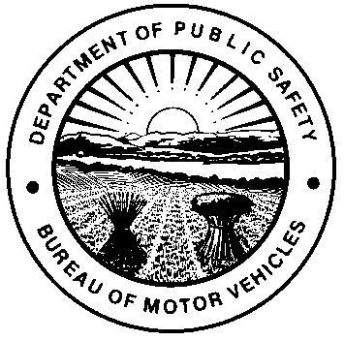 |  | OHIO DEPARTMENT OF PUBLIC SAFETY  BUREAU OF MOTOR VEHICLES  AFFIDAVIT FOR TITLING ALL-PURPOSE VEHICLE, MINI-TRUCK, UTILITY VEHICLE, AND UNDER-SPEED VEHICLE  Ohio Revised Code (R.C.) 4501.01, 4519.01, 4511.214 and 4511.215
I understand this form is for ownership ONLY and required when applying for a certificate of title. Unless being titled by a motor vehicle dealer, I further understand it is my responsibility to identify the vehicle accurately.
PLEASE PRINT LEGIBLY
OWNER NAME(S)

STREET ADDRESS (List business address if being titled in company name)

CITY |  |  |  |  | STATE |  |  | ZIP CODE
VEHICLE IDENTIFICATION NUMBER (VIN)

YEAR |  |  | MAKE |  | MODEL
The vehicle was designed exclusively for and should be categorized as the following (select one):
 | AT - All-Purpose Vehicle, means any self-propelled vehicle designed primarily for cross-country travel on land and water, or on more than one type of terrain, and steered by wheels or caterpillar treads, or any combination thereof, including vehicles that operate on a cushion of air, vehicles commonly known as all-terrain vehicles, all-season vehicles, mini-bikes, and trail bikes.
 | MT - Mini-Truck, which resembles a pickup truck or van with a cargo area/bed at the rear and has four wheels, is propelled by an electric motor with a rated power of 7,500 watts or less or an internal combustion engine with a piston displacement capacity of 660 cc or less, has a total dry weight of 900 – 2,200 pounds, and contains an enclosed cabin and a seat for the operator.
 | UV - Utility Vehicle, which was designed with a bed, principally for transporting material/cargo in connection with construction, agricultural, forestry, grounds maintenance, lawn and garden, materials handling, or similar activities.
 | US - Under-Speed Vehicle, (including what is commonly known as a golf cart), which has three or four wheels, an attainable speed of not more than 20 mph, and a gross vehicle weight of less than 3,000 pounds.
I, as the owner or authorized representative titling this vehicle, acknowledge that all information in this affidavit and in any additional documentation accompanying this affidavit is true and correct. Falsifying this affidavit is punishable by fine and imprisonment as pursuant to R.C. 2921.13. Please note a clerk may request additional information if there is a discrepancy in the record that may conflict with the desired vehicle category. Previous title application categories and submitted documents will be considered when approving the application for title.
PRINTED NAME |  |  |  |  |  |  | POSITION (IF COMPANY OWNED)
SIGNATURE
X
Sworn to and subscribed in my presence this day of , 20 in County,
State of .
(Notary Seal)
X My commission expires
Signature of Notary Public or other Authorized Officer by law
NOTE: A motor vehicle dealer licensed in accordance with 4517 of the R.C., who is the owner or purchaser of the motor vehicle, is not required to have this document notarized under section 4505.063 of the R.C.
ALL-PURPOSE VEHICLE, MINI-TRUCK, UTILITY VEHICLE, AND UNDER-SPEED VEHICLE
FREQUENTLY ASKED QUESTIONS
Notice: For your records only; do not submit with the title application.
- May I operate my vehicle on public roadways?
If intending to use the MT, UV, US on limited roadways in jurisdictions which allow it, the vehicle must be registered. An inspection from local law enforcement is required prior to applying for registration per R.C. 4511.215, Ohio Administrative Code (O.A.C.) 4501-30-01, and O.A.C. 4501-30-02. Visit ohiobmv.gov for the inspection form (DPS 1373) and additional information about unconventional vehicles.
- Why am I being asked to complete this affidavit?
This form is used to properly classify the vehicle based on its design and intended use. Because ATs, UVs, USs and MTs have distinct physical characteristics and different regulatory requirements under Ohio law, the applicant must identify which category applies. This ensures the vehicle is titled and processed correctly according to its specific definition and sales requirements.
- Is an Ohio title required by law?
AT: Yes, required to be titled per Ohio law.
UV, US, and MT: No, these are not required to be titled per Ohio law. These are titled for ownership purposes only and required for registration purposes on roads of 35 mph or less.
- Do I need an Ohio dealer permit number to sell a new AT, UV, US, or MT?
For an initial sale of an AT, the transaction must have originated from a licensed motor vehicle dealer under Ohio’s dealer licensing law (R.C.) 4517.01. For an initial sale of a UV, US or MT the transaction does not have to originate from a licensed motor vehicle dealer.
- What happens if the vehicle is misclassified?
If the vehicle is misclassified, the title application may be delayed or reviewed. The seller may also be investigated for selling a motor vehicle without a license when law requires the vehicle to be sold by a licensed dealer.
Vehicle Type |  |  |  | Definition |  | Example Photo
All-Purpose Vehicle (AT)  (R.C. 4519.01) |  |  |  | Means any self-propelled vehicle designed primarily for cross-country travel on land and water, or on more than one type of terrain, and steered by wheels or caterpillar treads, or any combination thereof, including vehicles that operate on a cushion of air, vehicles commonly known as all-terrain vehicles, all-season vehicles, mini-bikes, and trail bikes. |  | 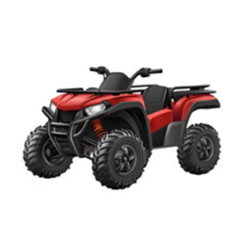 |  |  | 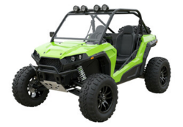
Mini-Truck (MT)  (R.C. 4519.01 & 4501.01) |  |  |  | Means a vehicle which resembles a pickup truck or van with a cargo area/bed at the rear and has four wheels, is propelled by an electric motor with a rated power of 7,500 watts or less or an internal combustion engine with a piston displacement capacity of 660 cc or less, has a total dry weight of 900 – 2,200 pounds, and contains an enclosed cabin and a seat for the operator. |  | 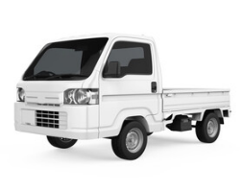 |  |  | 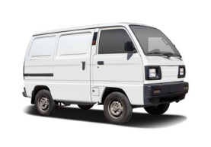
Utility Vehicle (UV)  (R.C. 4501.01) |  |  |  | Means a self-propelled vehicle designed with a bed, principally for the purpose of transporting material or cargo in connection with construction, agricultural, forestry, grounds maintenance, lawn and garden, materials handling, or similar activities. |  | 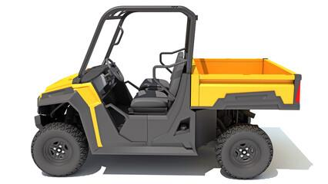 |  |  | 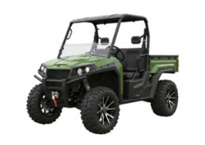
Under-Speed Vehicle (US)  (R.C. 4501.01) |  |  |  | Means a vehicle (including what is commonly known as a golf cart), which has three or four wheels, an attainable speed of not more than 20 mph, and a gross vehicle weight of less than 3,000 pounds. |  | 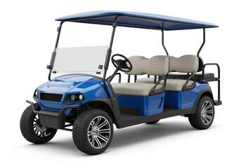 |  |  | 